**CSA User Profiles – my profile**

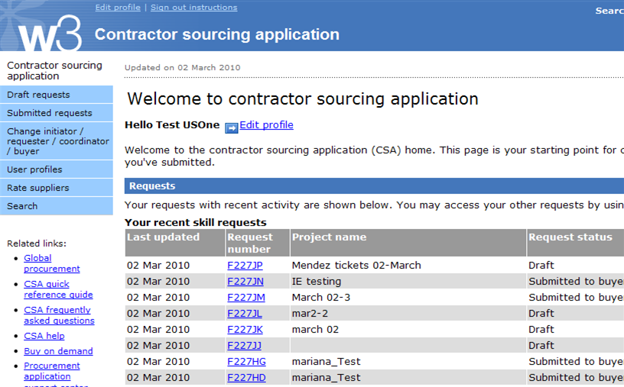

**To create a profile for someone else**

**To create or edit your current profile**

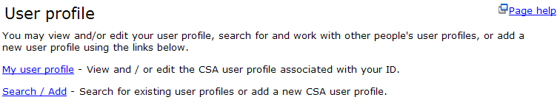

**Completing the CSA user profile**

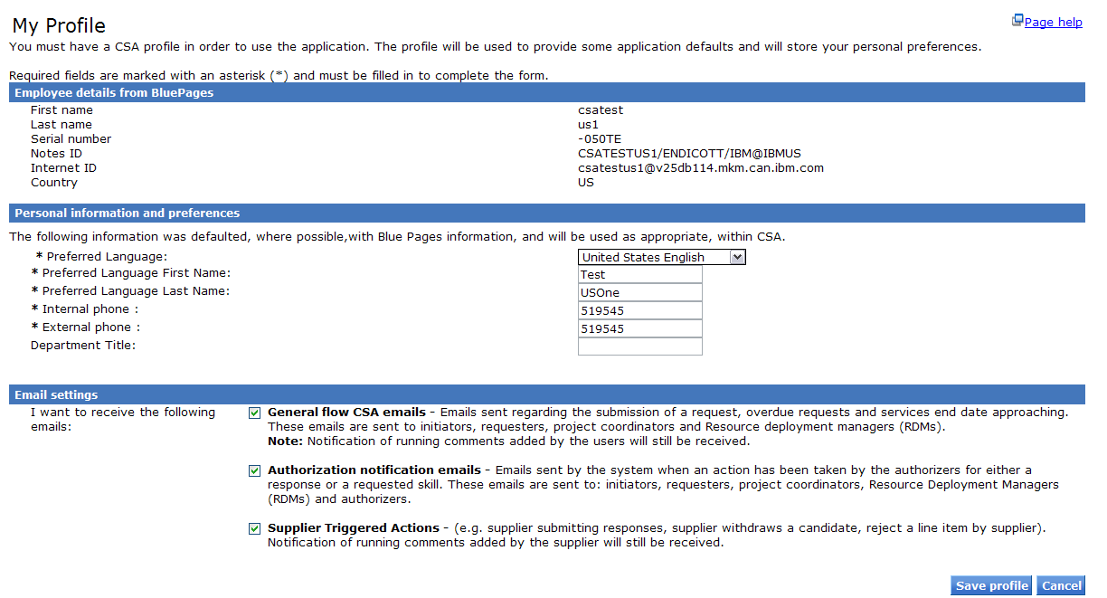

**Complete all Mandatory fields with an asterisk. Your chosen language and name will be viewable to Suppliers on CSA requests.**

**Note:**

* Pls contact procurement CSP to get responsible buyer to add your name to “project coordinator” & PM to “response reviewer” if you can’t search out the CSA
* Pls use “Running comments” function to inform PM(response reviewer) & buyer when 1)end user contract signed, 2)receive PR request from PM: **all PR must be submitted thru CSA to BOND for CSA case**
* If have multiple project code with one milestone, pls must inform buyer to create more items, normally, buyer base on SOW milestone to create item

**Running Comments**

Pls use “Running comments” to inform internal parties

1)end user contract signed back: select all internal parties including “Requesters”, “Buyers” and “Response reviewer” but exclude “Suppliers”

2)receive PR request from PM: inform all parties and add comment “To buyer: pls prepare purchase requisition”. If have multiple project code with one milestone, pls add comment to inform buyer to create more items.

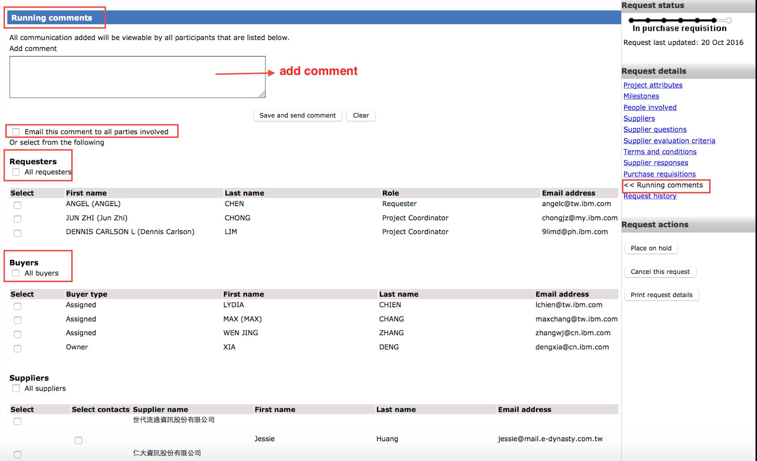



Part 3 Submit CSA to BOND Create purchase requisition

1,Log in CSA and find the csa request ,the status is In Purchase requisition and click the request number

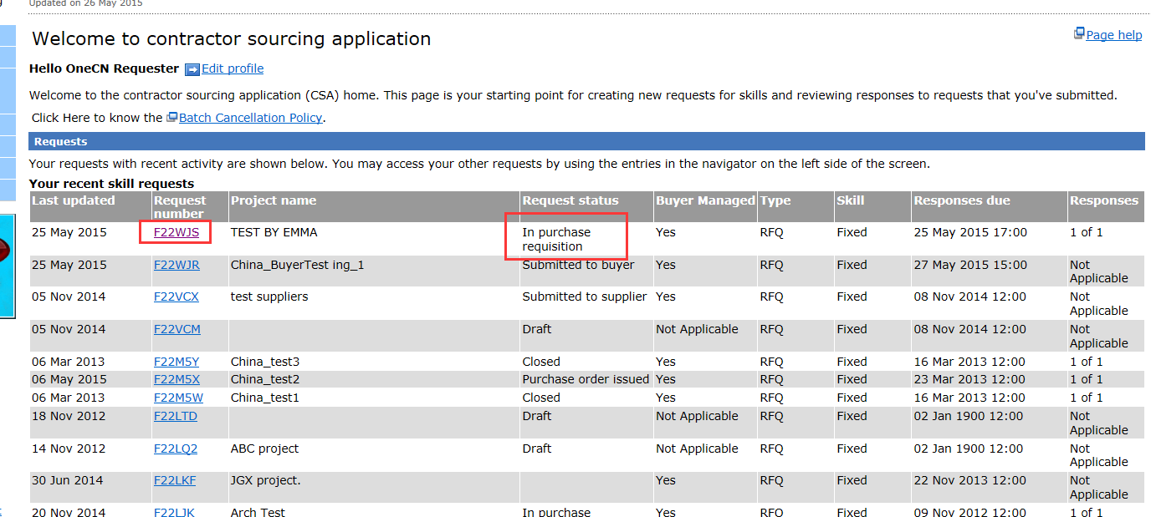

2, Click the purchase requisition ID ,status is in waiting submission 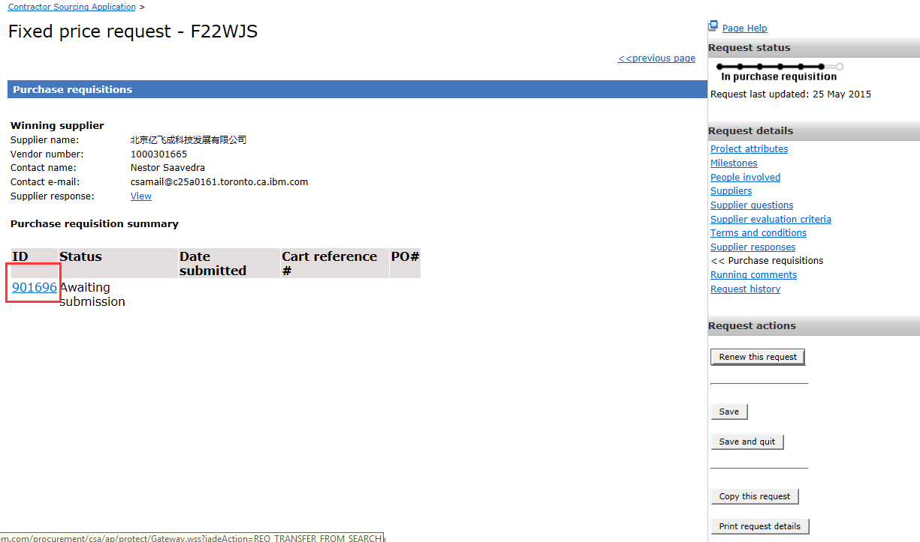

3. Review the purchase requisition and fulfill parts with asterisk or other required/necessary information, like”, change requester to PM →create purchase requisition

Note: buyer base on SOW milestone to create item, if have multiple project code with one milestone, CSO must inform buyer to create more items when request buyer to create purchase requisition

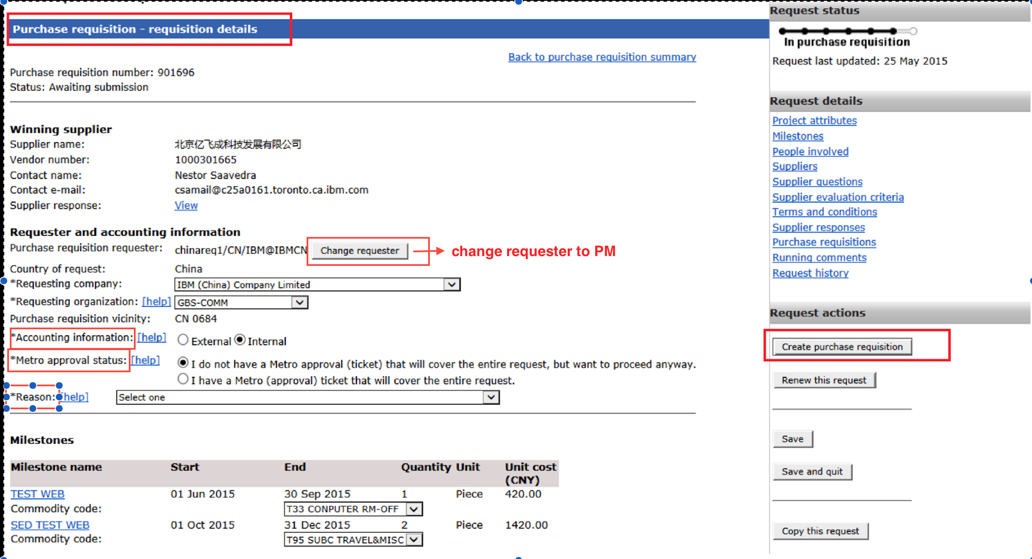

4. edit or add more milestone before proceed “create purchase requisition”: if you need to update milestone information then click on the “Milestone name”. You can add additional milestone if needed(for multiple project with one milestone but not inform buyer to create more items)

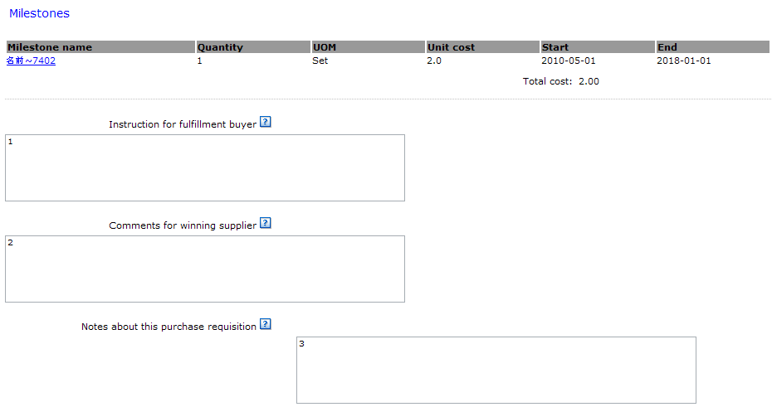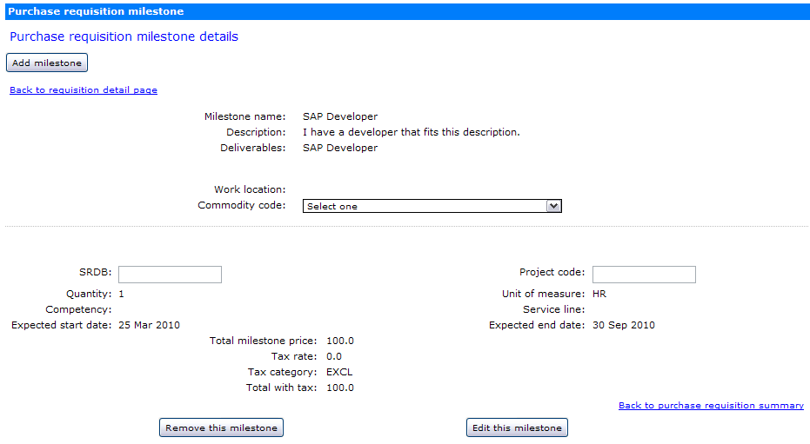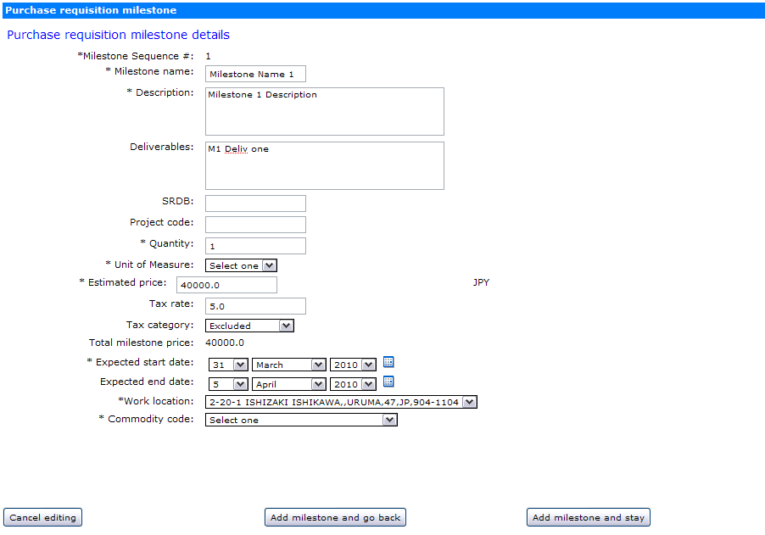

**The default milestones comes from the winning Supplier’s response. You will be able to edit the milestones as needed and enter in the commodity code for each milestone. You can also add additional milestones if needed.**

5. The status will be submitted and cart number will be generated .click cart reference to BOND and complete BOND process

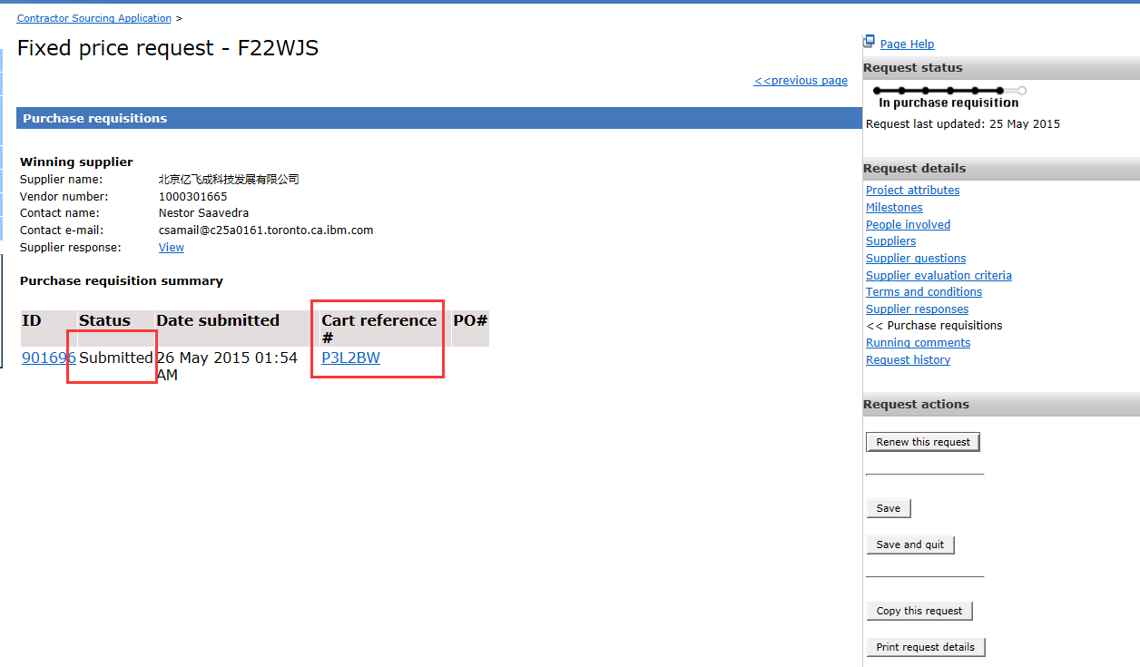

Part 4 BOND process

1, Click cart reference →Log in BOND →Current cart ,click current cart ,detail of the cart will pop up

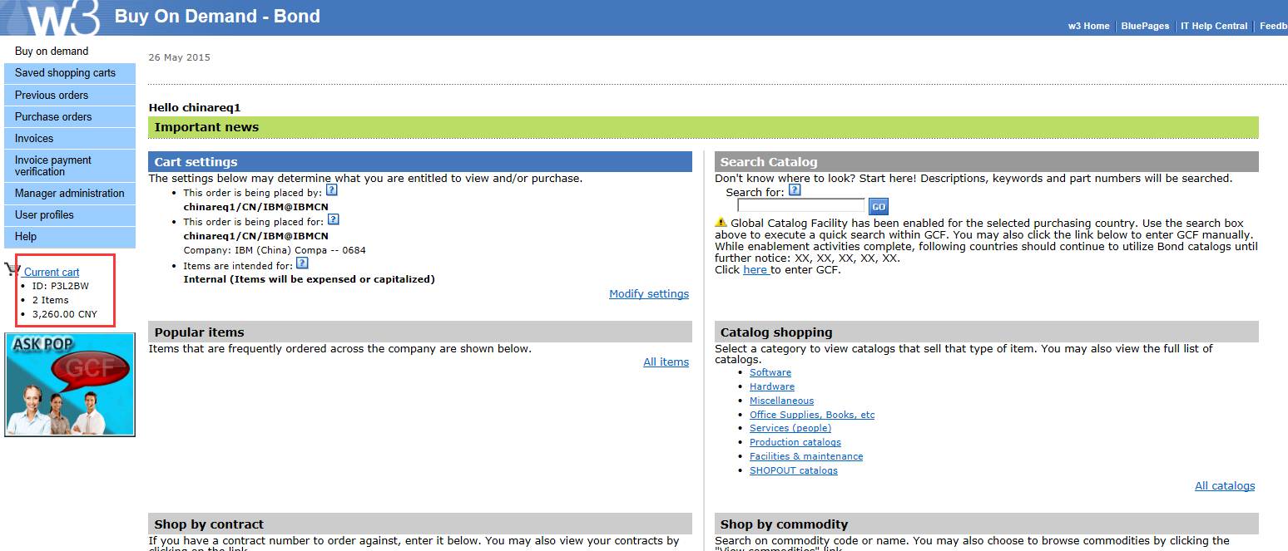

2, The two milestones turn into two items →check out finish and complete the following process

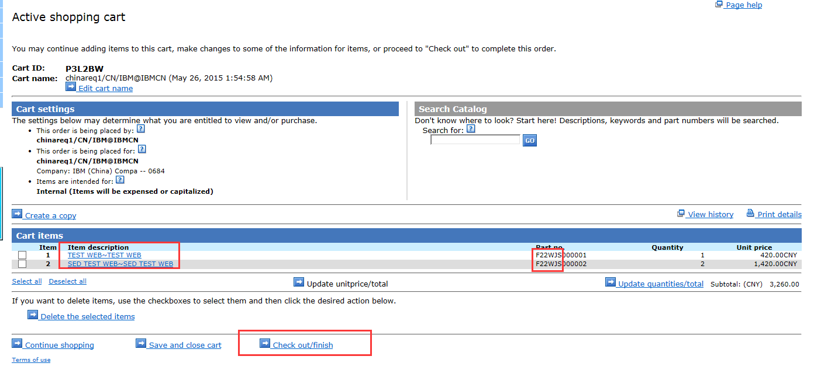

3, Click Continue to next step

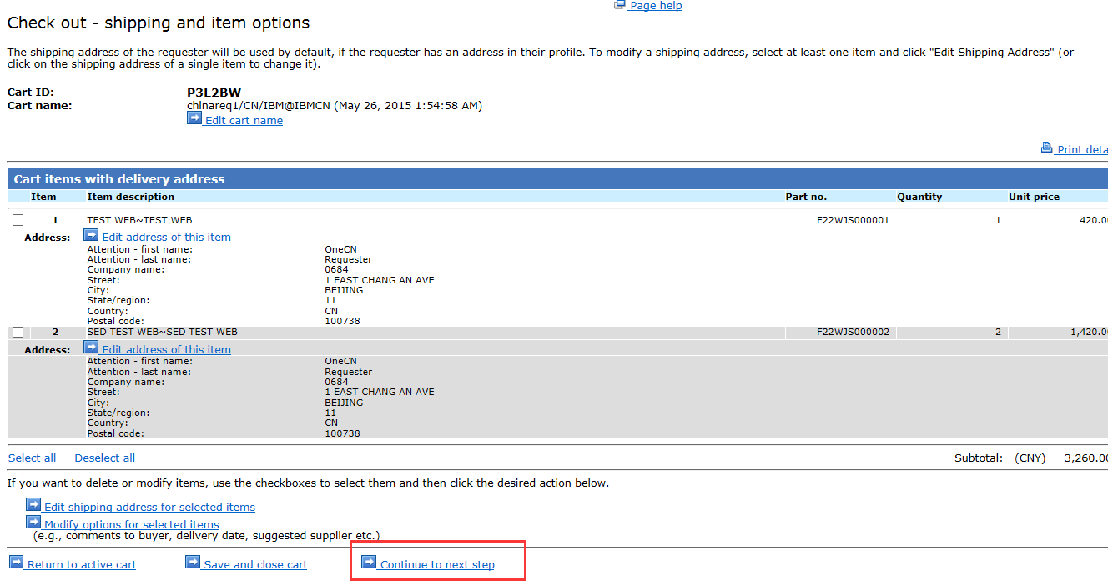

4 ,Select “product category” if need and continue to next step

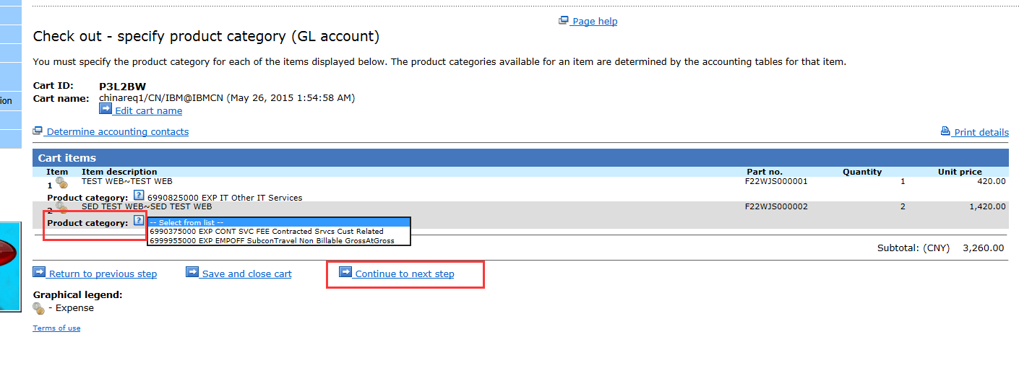

5, Click “Edit accounting step by step” to input accounting information

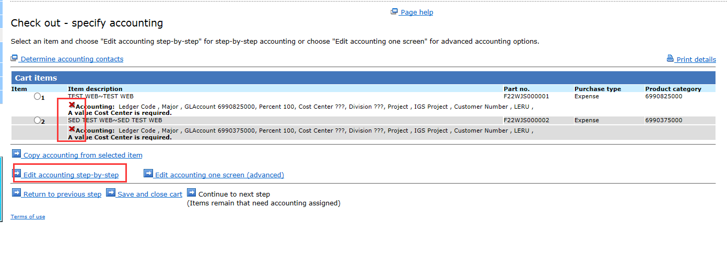

6, Input cost center and click next step

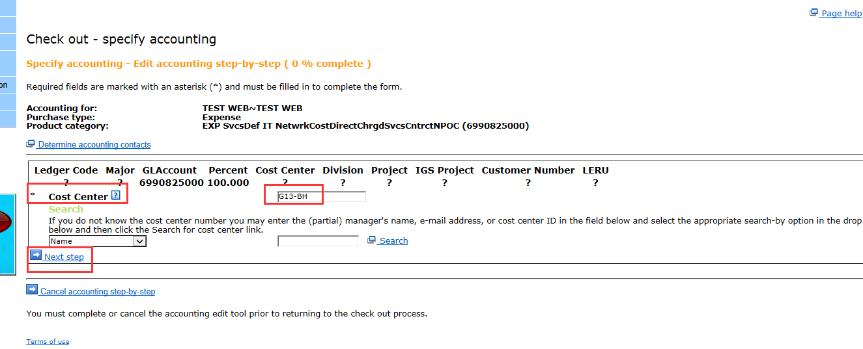

7,click Continue next step

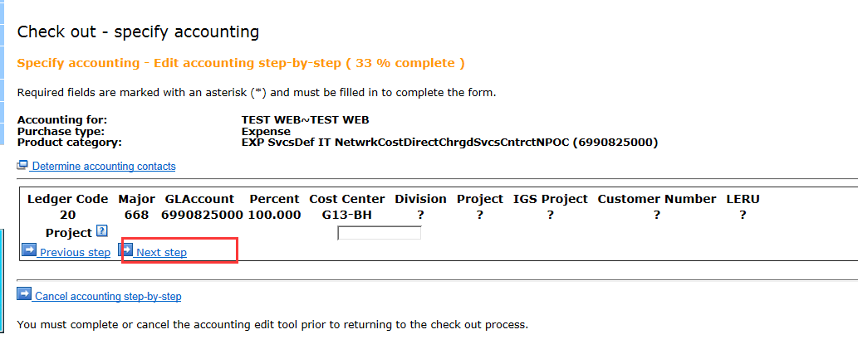

8,click “next step”

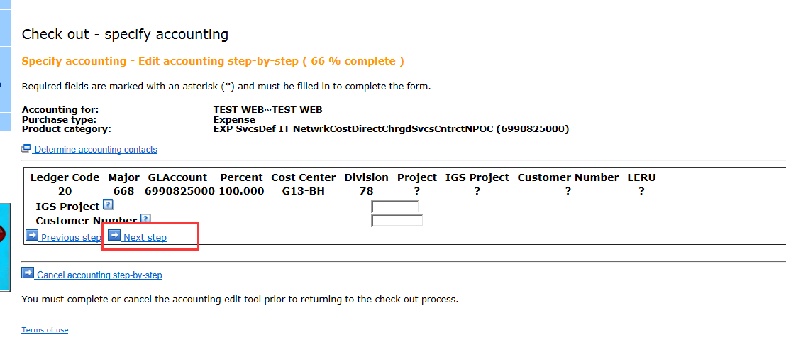

9,Click finish

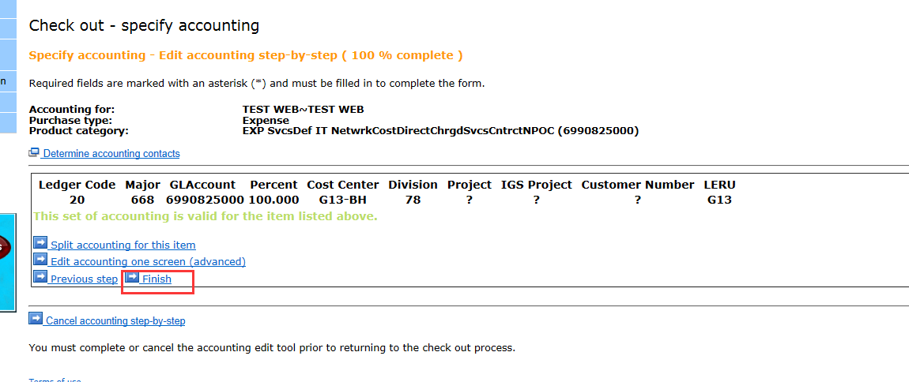10,main page of accounting →Select the item which accounting is correct →copy accounting from selected item

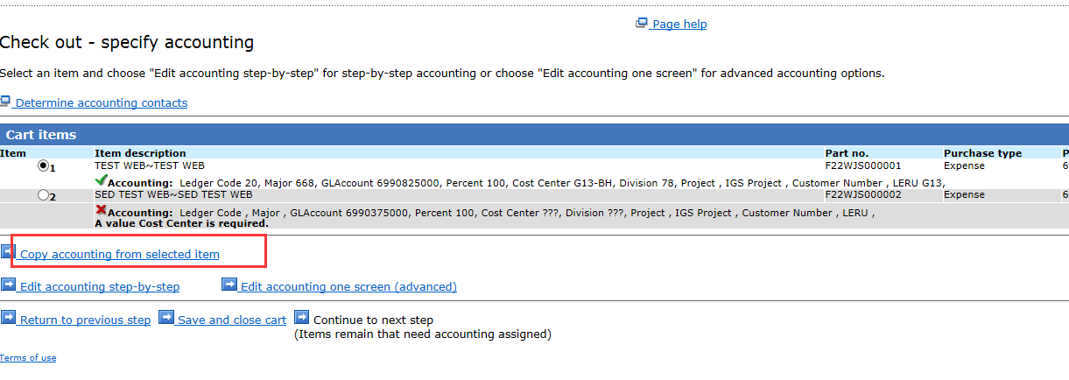

11,Click “Select all” and “copy accounting to selected items”

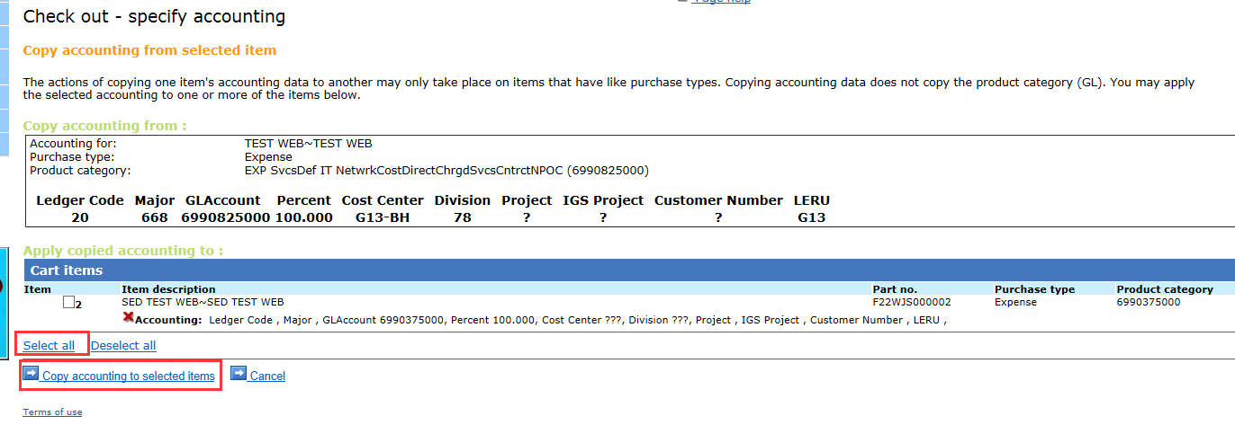

12 The accounting information has been input for the two item and continue to next step

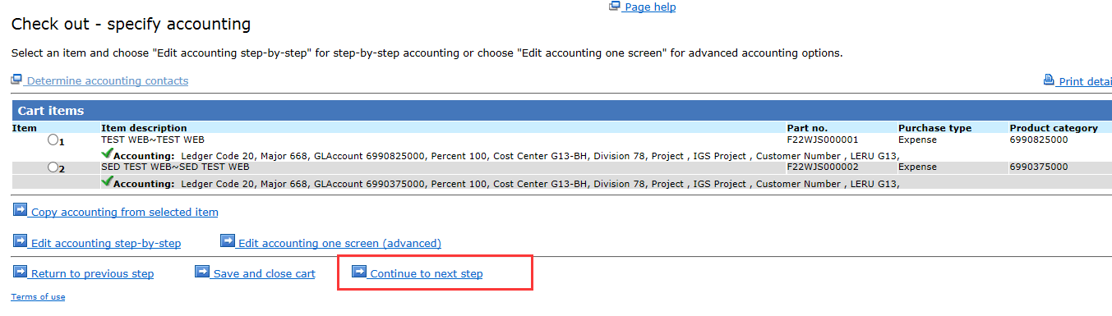

13 You may check buyer information &approvers and reviews and input business justification

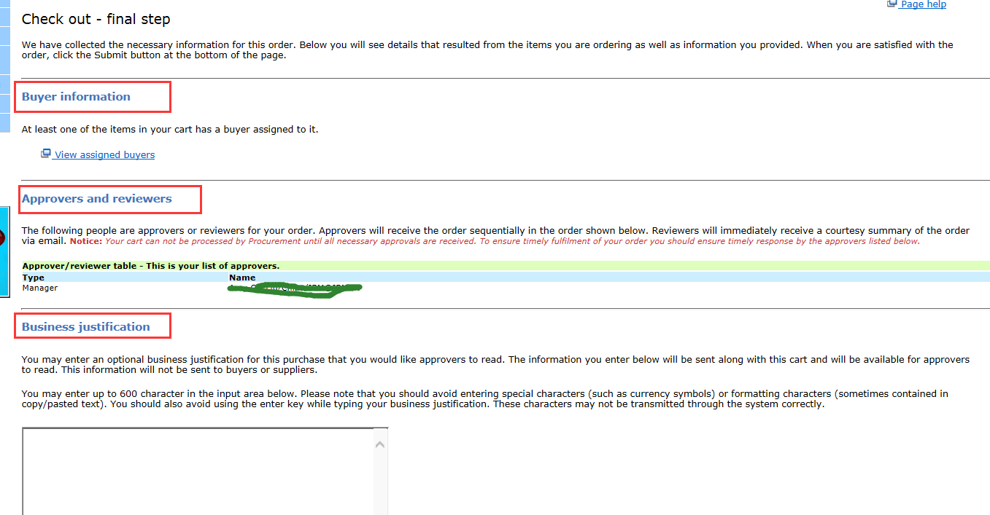

14 The final step is submit your order ,the process complete

